AICTE File No. | F.No. South-West/ 1-7003419112 /2020/EOA
AICTE ID. | 1-6181978
Date & Period of last approval | 13.06.2020
Name of the Institution | Indira Gandhi Institute of Polytechnic and Engineering
Address of the Institution | Nellikuzhy P.O,Kothamangalam
Location map of the Institution | 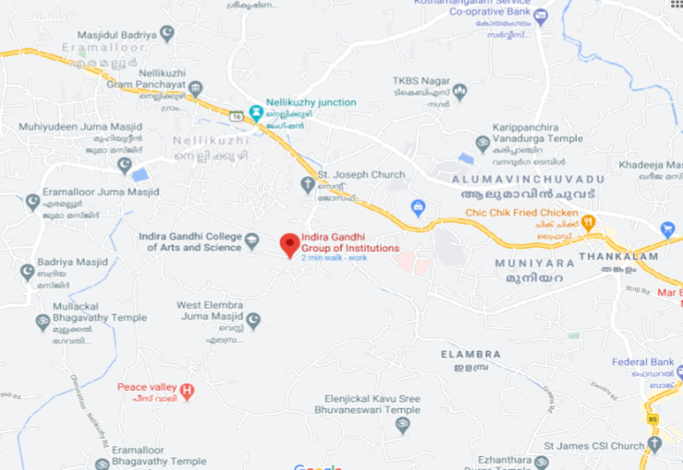
City & Pin Code | Kothamangalam-686691
State | Kerala
Longitude & Latitude | 10°04'05.3"N 76°35'44.0"E
Phone number with STD code | 0485 282 7740
FAX number with STD code | 0485-2827740
Office hours at the Institution | 9.00 AM to 4.30 PM
Academic hours at the Institution | 9.00 AM to 4.00 PM
Email | info@iipe.in
Website | www.iipe.in
Nearest Railway Station | Aluva, 31Km away
Nearest Airport | Cochin International airport, 31 Km away
Type of Institution | Self Financing
Category (1) of the Institution | Minority,
Category (2) of the Institution | Co-Ed
Name of the organization running  the Institution | Indira Gandhi Memorial Trust
Type of the organization | Trust
Address of the organization | Indira Gandhi Institute of Polytechnic and Engineering Nellikuzhy P.O,  Kothamangalam, PO-686691
Registration date | 29/08/2001
Website of the organization | www.iggis.org
Name of the affiliating University/ Board (PG,UG) | APJ Abdul Kalam Technological University,  Thiruvananthapuram

Address | APJ Abdul Kalam Technological University, CET Campus, Ambady Nagar, Thiruvananthapuram,  Kerala 695016
Website | www.ktu.edu.in
Name of the affiliating University / Board (Diploma) | State Board of Technical Education(SBTE)
Address | Padmavilasam Rd, Fort, Nalumukku, Pazhavangadi, Thiruvananthapuram, Kerala 695023
Website | www.sbte.kerala.gov.in
Latest affiliation period | Academic year 2021-2022
Name of Principal / Director | Dr. Justin Jose
Exact Designation | Principal in charge
Phone number with STD code | 0485 282 7740
FAX number with STD code | 0485 282 7740
Email | principal@iiet.org.in
Highest Degree | Ph.D
Field of specialization | COMPUTER SCIENCE ENGINEERING

Governing Board Members
Sl.  No | Designation | Name and Contact Details | Educational qualifications
1 | Chairman | K M Pareeth  PH:9447136101
2 | Vice Chairman | SAIREJ K.P  PH:9495943439
3 | Director Nominated by the society / trust | Shibu K.P
4 | Secretary Member Nominated by the society / trust | Dr. Shias K.P
5 | CEO Nominated by the society / trust | Dr. Siyad K.P
6 | Member Nominated by the society / trust

7 | Member  Nominee of AICTE / regional officer | Dr. Ramesh Unnikrishnan Director, Regional Office, AICTE Thiruvananthapuram  Ph: 04712596363  Email: aicte.tvpm@gmail.com | Ph D
9 | Member Nominee of University | Dr. G P Padmakumar Registrar, APJ Abdul Kalam Technological, University, Thiruvananthapuram  Ph: 04712598822  Email: registrar@ktu.edu.in | Ph D
11 | Principal of the institution | Dr. Justin Jose | Ph D
12 | Member Faculty of the Institution, nominated by Principal |  | Ph D
13 | Member Faculty of the Institution, nominated by Principal |  | Ph. D
Frequency of meetings |  |  | Twice in a year
Date of last meeting |  |  | 18.04.2020

Academic Advisory Body | Yes
Frequency of meetings | Twice in a year
Date of last meeting
Student feedback mechanism on Institutional  Governance/faculty performance | Feedback is taken in every semester
Grievance redressal mechanism for faculty, staff  and students | Available

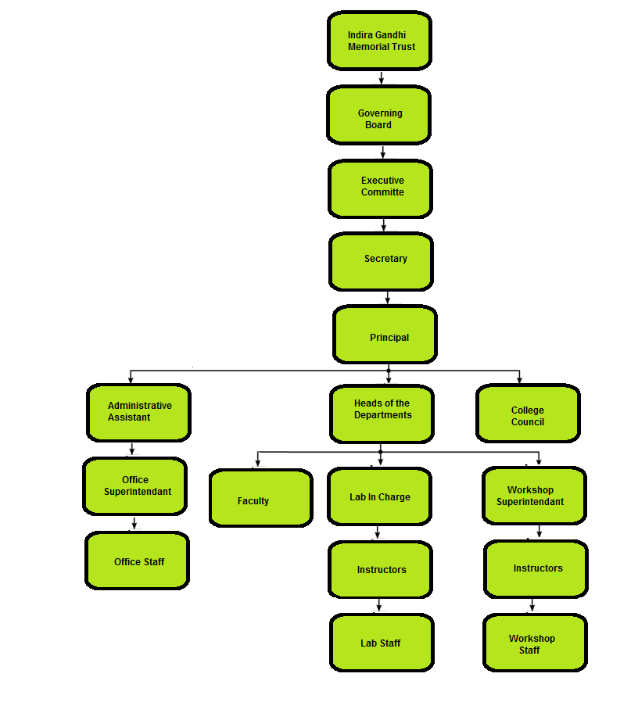
Organizational Chart

PROGRAMMES (UG)
Sl No. | Name of the Programme | No. of Seats | Duration
1. | Civil Engineering | 60 | 8 Semesters
2. | Electrical and Electronics Engineering | 30 | 8 Semesters
3. | Electronics & Communication Engineering | 30 | 8 Semesters
4. | Computer Science and Engineering | 60 | 8 Semesters

PROGRAMMES (PG)

Sl No. | Name of the Programme | No. of Seats | Duration
1. | CIVIL ENGINEERING(STRUCTURAL ENGINEERING AND CONSTRUCTION MANAGEMENT) | 18 | 4Semesters
2. | ELECTRONICS AND COMMUNICATION ENGINEERING(COMMUNICATION ENGINEERING) | 18 | 4 Semesters
3. | COMPUTER SCIENCE AND ENGINEERING(COMPUTER SCIENCE AND ENGINEERING) | 18 | 4 Semesters

PROGRAMMES (Deploma)

Sl No. | Name of the Programme | No. of Seats | Duration
1 | Civil Engineering | 60 | 6 Semesters
2 | Mechanical Engineering | 60 | 6 Semesters
3 | Automobile Engineering | 60 | 6 Semesters
4 | Tool And Die Engineering | 60 | 6 Semesters
5 | Electrical and Electronics Engineering | 60 | 6 Semesters

Vision of the Institution
To become an institute of great repute in the field of Engineering & Technology by offering a full range of programmes of global standard to foster research and to transform the students into globally competent personalities
Mission of the Institution
To provide all necessary inputs to the students for them to grow into knowledge engineers and scientists attaining and to motivate the students to pursue higher education, appear for competitive exams and other value added programmes for their holistic development.
- Excellence in domain knowledge- practice and theory.
- Excellence in co-curricular and extracurricular talents.
- Excellence in character and personality.

Important Facilities Available

College Library
Education system should be integration and co-ordination between the classroom and the library, which brings out the fruitful result in building up the overall development of the personality of the student. The library system consists of a central library and other department libraries. All students, faculty members and employees are entitled to avail the facilities of the Central Library after enrolling themselves for a membership. The library consists of textbooks by reputed authors, E journals, newspapers and magazines. The library is managed by fully qualified and experienced library professionals.
Internships/Industry Visits

Industrial visits are an integral part of the college curriculum for professional degrees. Its main objective is to offer an insight into the working of a factory or industrial unit. It also provides an opportunity to delve deeper into the realities of an Industrial house. The institution encourages students to conduct industrial visits on a regular basis. As per the syllabus, each student shall undergo internship during the vacation time.

National Service Scheme (NSS)
The programme aims at instilling the idea of social welfare in students, and to provide service to society without bias. NSS volunteers work to ensure that everyone who is needy gets help to enhance their standard of living and lead a life of dignity. In doing so, volunteers learn from people in villages how to lead a good life despite a scarcity of resources. It also provides help in natural and man-made disasters by providing food, clothing and first aid to the disaster's victims.

Internal Quality Assurance Cell (IQAC)
Since quality enhancement is a continuous process, the IQAC will become a part of an institution’s system and work towards realizing the goals of quality enhancement and sustenance. The motto of the IQAC is to achieve quality through continuous improvement with cooperation of all stake holders. The Internal Quality Assurance Cell gives advice and guidelines to the administration to maintain high quality work in academics and administration. The cell monitors the quality aspects of all the academic and non-academic activities of the institution. The cell works on various accreditation aspects
Functions
- Taking a lead role in undertaking Academic Audit and to give feedback with the purpose of devising quality enhancement programmes.
- Facilitating the creation of a learner-centric environment conducive for quality education and faculty maturation to adopt the required knowledge and technology for participatory teaching and learning process.
- Arrangement for feedback responses from students, parents and other stakeholders on quality related institutional processes.
- Dissemination of information on the various quality parameters of higher education.

Anti-ragging Committee

Anti -Ragging Committee is constituted in the college to prevent ragging and to take anti-ragging measures as per the guide lines issued by the Supreme Court of India Actions will be taken against students for indulging and abetting ragging depending upon the nature and gravity of the offence as established. On admission to the college, each student will be asked to sign the anti- ragging oath form that creates awareness about ragging offences and punishments. The Anti-ragging committee conduct enquiry on complainants and submits report to the Principal. The Principal, if required, forward the complainant to the local police for necessary action against the offender. The committee keeps the records of the complaint and the enquiry report prepared (if any) in all cases.

Women’s Cell
Women cell aims at empowering and orienting women to recognize their true potential and to help them attain their own stand in a competing world. Its goal is the overall development in all spheres of their life. The main functions of Women cell are;
- Enable the students and teachers to come to the forefront and maintain a harmonious environment in the institute.
- Create awareness on gender related issues.
- Create a professional learning and working atmosphere in the institute for its students and employees by preventing gender discrimination.

Internal Complaints Committee

An Internal Complaints Committee (ICC) is formed in this institution according to the provisions of the Sexual Harassment of Women at workplace (Prevention, Prohibition and Redressal) Act, 2013.

Student’s Grievance Cell
The objective of the Grievance Cell is to develop a responsive and accountable attitude among all the stakeholders in order to maintain a harmonious educational atmosphere in the institute. Grievance Cell facilitates the resolution of grievances in a fair and impartial manner involving the respective Department .The function of the cell is to look into the complaints lodged by any student, and judge its merit Anyone with a genuine grievance may approach the faculty members in person, or the officer in-charge Students’ Grievance Cell.

Students Welfare Committee
The purpose of the Welfare committee is to promote student welfare, advice and support. We achieve this by campaigning on various welfare issues, as well as by working with student-led services. Under this committee, a counselling cell is provided with counsellor to mentor students having family problems and other issues so as to improve their mental as well as physical well-being.

Parent Teachers Association(PTA)
The PTA aspires for co-operation and participation of parents in full measure, in the wholesome activities of the college. . The PTA has been focusing on the growth and development of the college since its inception It actively involves in training and placement, also provides financial support to economically backward students.

